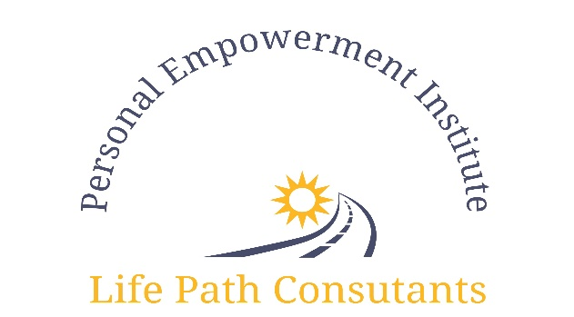

Midlife by Design

Presents

Next Chapter >>>>Career Path

Personal Life Path Consulting

Hosted by Your Facilitator:

Carolyn Catchings, LPC, CRC, Life Path Consultant

Presented in group and individual session formats.

For more information or registration please call (800-413-3057 or 314-413-9671

Or visit: www.midlifebydesign.org or www.personalempowermentinstitute.net

The Personal Empowerment Institute

has installed a new program

“Next Chapter >>>>Career Paths”
The next chapter of your life should be about your purpose because purpose brings fulfillment!

Carolyn Catchings (Life Path Consultant) will help you pave the path to your next business or career with passion and purpose.

The “Next Chapter>>>>Career Paths” program is offered in 2 formats & 2 segments:
6 (1 hour) weeks group and individual sessions or
Weekend Workshop (Friday evening 7 pm till 9pm, for introduction and orientation and Saturday workshops 10 am till 5pm, breakfast and lunch included)
Total cost: $1,500 per person (payment options available)

>> Discover Your Authentic Self
>> Unearth Buried Potential
>> Build Your Brand or Discover Your Calling
>> Find Your Market / Your Consumer
Event Locations:
9378 Olive, suite 201 or 4643 Lindell (Weekend Workshop)
Olivette, NO 63132 St. Louis, MO 63108
Limited Space Available / Early Registration Required
For upcoming dates & registration packet
Please call 800-413-3047 or 314-413-9671
to reserve your seat today
Hotel accommodations (optional)

​

